# FACT SHEET: The Cult of the Dioscuri in Rome

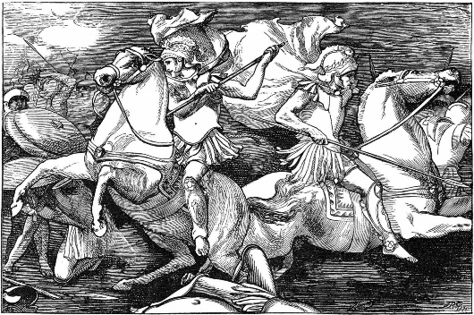Who are the Dioscuri?

Castor and Pollux became known as the Dioscuri, meaning “Sons of Zeus” were twin half-brothers born to human mother Leda, Queen of Sparta. Castor’s father was Leda’s husband Tyndareus, and Pollux’s father was the lead god of the Olympians, Zeus (Or Jupiter in Roman mythology). After Castor was murdered by Idas and Lynceus, the ex-fiancés of the women Castor and Pollux planned to marry, Pollux killed Lynceus and Zeus struck down Idas. Zeus had just offered immortality to his son Pollux, but Pollux asked if he could share his immortality with his brother, and so the pair split their time between Olympus and the Underworld.

The Dioscuri were known as helpers of mankind, and patrons of travellers and of sailors in particular. Because the pair were also known as skilled horsemen and boxers, they also became patrons of athletes and athletic competitions. Worshippers of the Dioscuri would leave offerings for favourable winds before they set sail.

The Cult of the Dioscuri in Rome

The cult of the Dioscuri became established in Rome in the early 5th century BCE, in particular after the Battle of Lake Regillus in 496BCE between Rome and the Latin League led by the last king of Rome, Tarquinius, who had been expelled in 509BCE. The legend says that Castor and Pollux played a major role in the battle, aiding the Roman army as they captured the Latin camp. The legend continues saying that the two appirations arrived in Rome and led their exhausted horses to the Forum where they drank from the fountain near the Temple of Vesta and announced the victory of the Romans to those in the Forum. To celebrate the victory, the Temple of Castor and Pollux was dedicated by Roman general Aulus Postumius in 484BCE. The cult of the Dioscuri held a more important part of Roman religion than of Greek religion, and became a key part of Roman beliefs and practices. They were still patrons of sailors and athletes, but were also known for their roles in war and depicted as symbols of victory.

The Dioscuri on Roman Coins

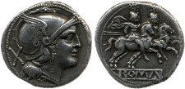During the 3rd century BCE Rome and its Colonies were fighting the First Punic War (BCE). Because of their role in the Battle of Lake Regillus, the Dioscuri were known as symbols of victory among the Romans. During the First Punic War Rome and its colonies would use victory symbols on their coins, and both Rome and Suessa Aurunca, a colony in Campania chose to use images of Castor and Pollux. On Roman coins they are often depicted as a pair, wearing a conical felt sailor’s hat known as *pileus*, and on horseback. Sometimes they are depicted standing naked, leading a horse in one hand and holding a spear in the other. The coin in the artefact study is a little bit different, but still follows the themes of victory used for the Dioscuri. Only one of the pair is shown, however he is still wearing the *pileus* hat and on horseback while leading another. The filleted palm leaf he’s carrying over his shoulder is also a symbol of victory.

# Artefact Study

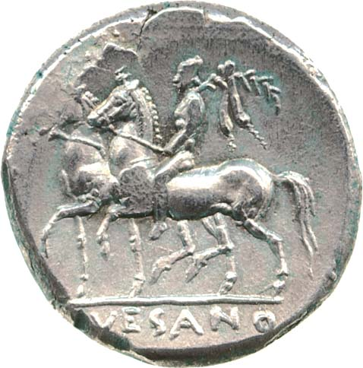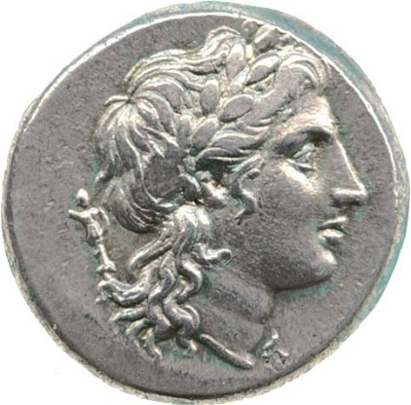This silver coin is a didrachm. It was minted some time between 265-240BCE. The obverse (heads) depicts the head of Apollo with a laurel wreath on his head in front of a small trophy. In Roman mythology Apollo was the deity of healing and prophecy. The reverse (tails) of the coin depicts one of the Dioscuri on horseback and leading a second horse beside him. He’s wearing the conical felt *pileus* hat used by sailors and carrying a filleted palm leaf over his shoulder. The exergue (written section under the reverse image) reads “SUESANO”, which means “of the Suessans”.

Suessa Aurunca was a Roman colony in southern Italy founded in 313BCE and was surrounded by both Roman colonies like Cales, and Greek colonies of Magna Graecia like Apulia, Calabria, and Basilicata. At the time this coin was minted, Rome and its colonies were fighting the First Punic War against Carthage. The colonies paid and set young men to be soldiers and help the war effort. This coin type was most likely used to pay soldiers from Suessa Aurunca to participate as part of the Roman army.

Question Time:

1. Why might the Suessans have written “of the Suessans” on their coins?
2. Take a look at the images of the Dioscuri on the coin from Suessa Aurunca on this page and the one from Rome on the fact sheet. What similarities can you see in these images? What differences can you see?
3. Why might the Suessan’s have used a coin with an image of the Dioscuri on it?